Lab Assignment-3

Mash up Application

The mashup application is integration of Goople Maps and Twitter API's.

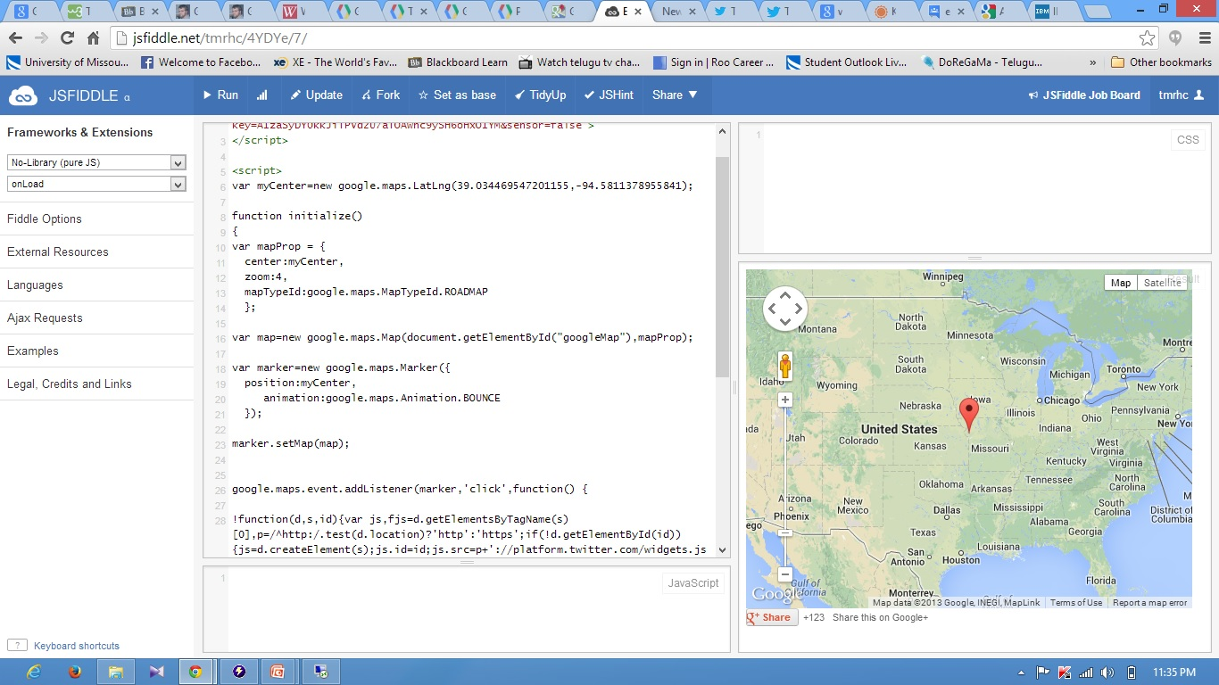

Google Map will be pointed to the location coordinates as given in the code.

When clicked on the marker it will be zoomed onto Student union of the UMKC campus and Tiwtter follow button to follow twitter account will appears on the screen.

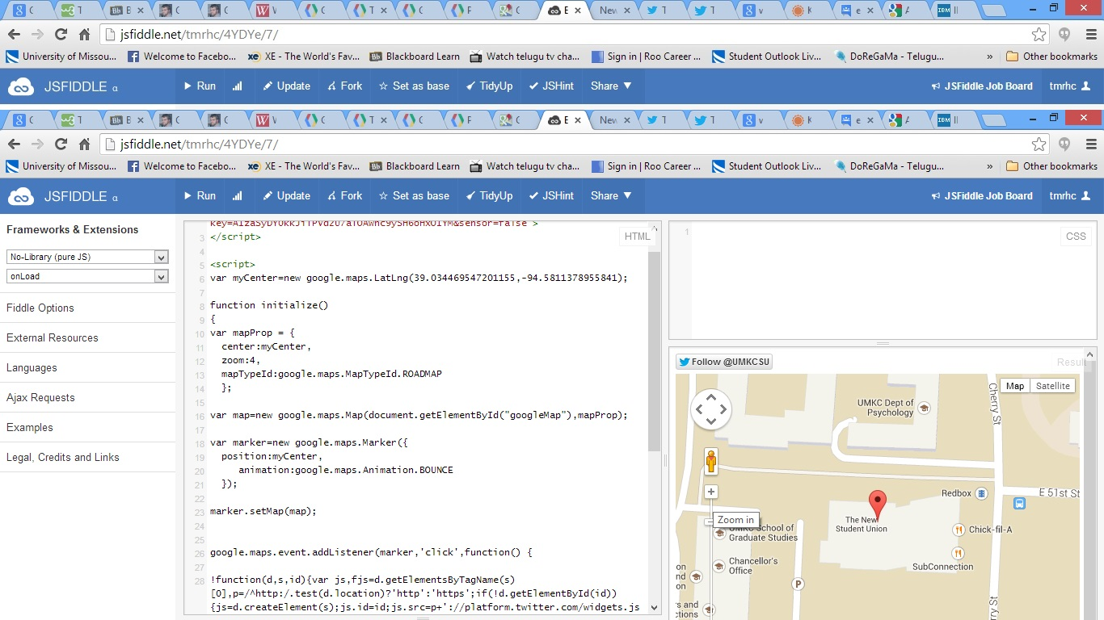

When clicked on follow UMKC-SU it will be redirected to twitter page to follow the Student Union account.

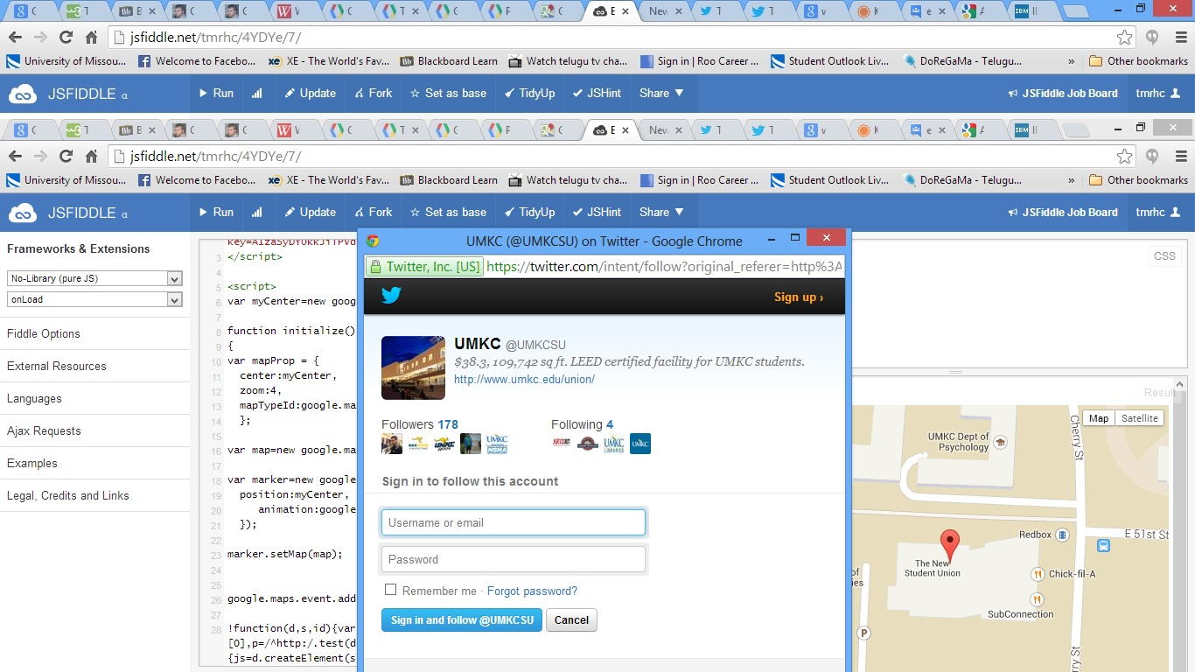

In addition to this Google Plus addin can be seen on the screen under the map.

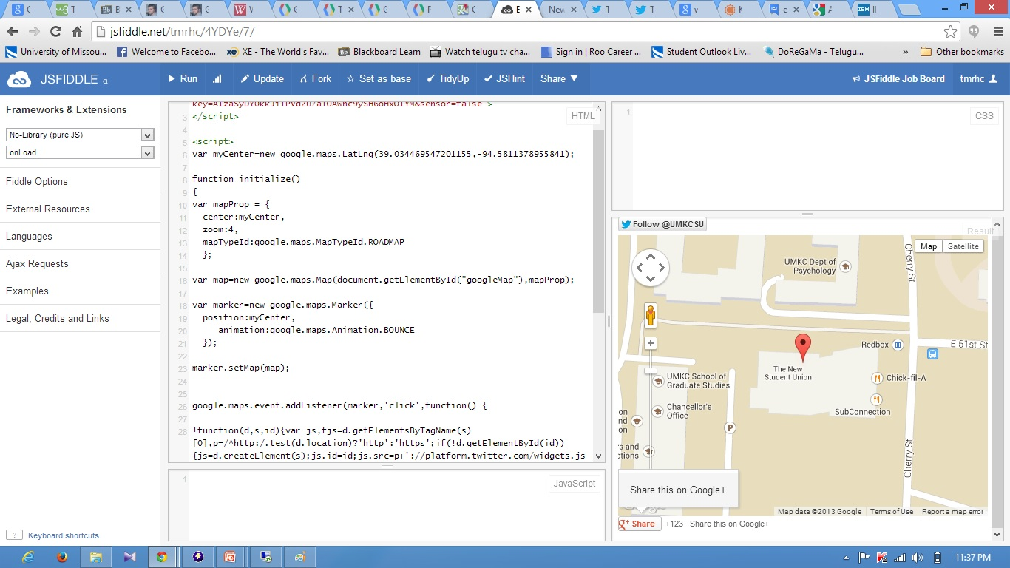

when clicked on the button it will be shared through google plus.

